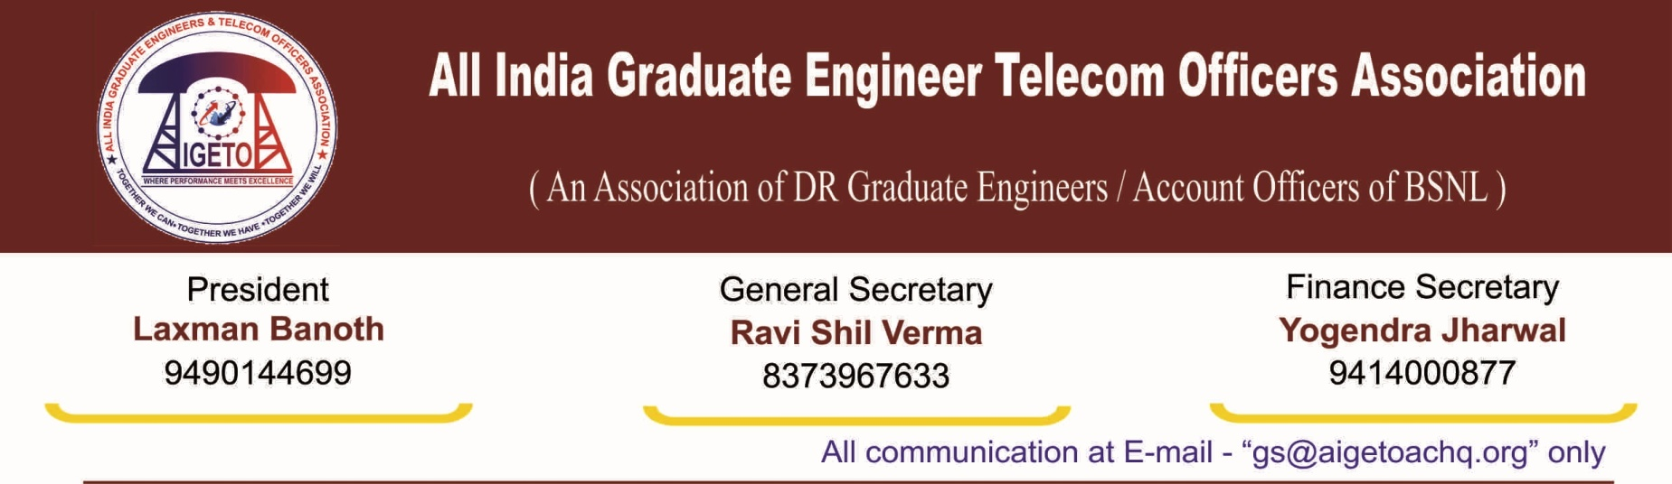
No. GS/AIGETOA/2016/19 Dated 19.08.2016

To,
Shri Manoj Sinha
Hon’ble Minister of State (I/C) for Communication
Government of India, New Delhi.

Respected Sir,
We congratulate and extend our best wishes to you on assuming the charge of Minister of State (I/C) for Communication on behalf of all BSNL Recruited Engineers & Account Officers under the umbrella of AIGETOA [All India Graduate Engineers & Telecom Officers Association]. We, the youngest executives of BSNL, firmly believe that your proficient leadership will speed up the growth trajectory of BSNL from its current recovery path to new height of success in the world of telecommunication by incorporating professionalism and accountability at all level with proper Government support to the organization.
Sir, BSNL is on the recovery path under the patronage of current NDA Government after posting losses for many years. The company has already arrived in profit zone by posting operating profit of Rs 623 Crore in 2014-15 and expecting Rs 2200 Crore in 2015-16. We are confident that the direction of the Central Government and dedication of management & employees will bring back the past glory to BSNL.
The company while having every resource which can take it to the top of all successful PSUs, was suffering mainly because of lack of business centric approach, lack of professionalism, lack of contemporary policies, continued investment into projects which have turned into white elephants for BSNL, demotivation amongst employees owing to lack of contemporary HR policies, persistent neglect of qualified and young talent etc. We are happy that the present management is taking keen effort to bring professionalism in business under guidance of Hon’ble Minister and hence perception of public towards BSNL is changing as flourishing company for the nation building.
But the issues which were needed to be deliberated on the very first day of formation of BSNL has not seen light of the day even after passing of sixteen years. Our submission is emboldened by the fact that still in its 16th year of operation, BSNL has not implemented a contemporary performance oriented HR Policy where carrots come with performance and stick comes with non-performance. It’s an irony in BSNL that an executive recruited by BSNL in 2001 is still waiting for its first promotion even after more than fifteen years of service with all professional qualification in his kitty.
The core strength of any organization is its human resource, which can build or break a brand but unfortunately it is the most ignored lot in BSNL and that too specially the young and qualified executives recruited by BSNL who has vast contribution in the turnaround of the company.
The young and dynamic employees of BSNL have been kept deprived of their very basic entitlements like Pay, Promotion & Pension (PPP). BSNL is extending Financial upgradation but the functional responsibilities associated with it are being not given in the name of legacy issues.
The 2nd PRC recommendation was implemented in all the CPSUs with spirit to counter global inflation and distribution of country’s growth among the citizens, but the youngest lot of BSNL employees have been forced to accept a compromised remuneration wherein, their salary has been reduced by six to eight thousand. The future security aspect of BSNL recruited employees; which was very clearly outlined by second PRC has been denied and kept pending by BSNL management either on one pretext or another. BSNL has not extended superannuation benefits to the employees directly recruited by BSNL despite provisions clearly stated in the presidential orders and DPE guidelines. We would like to draw your kind attention on following points being faced by the BSNL recruited executives:

Standard Pay Scale of E2-E3 to JTO-SDE equivalent in BSNL:
In accordance with the recommendations of 2nd PRC, non-standard scales of E1A & E2A for JTO & SDE equivalent were to be replaced by E2 & E3 w.e.f. 1-1-2007 in BSNL. After a long struggle and continuous persuasion of nine years, BSNL finally approved the proposal of standard scale of E2 & E3 for JTO & SDE equivalent w.e.f. 01-01-2007 and sent the recommendations to DoT for consent in June’2016. The proposal is now with Department of Telecommunication for their early assent. The next PRC is due from 01-01-2017 and non settlement of the standard scale will result in a loss of more than ten thousand to the JTOs/JAOs recruited after 01-01-2007 and may be serious setback to a huge chunk of young and qualified executives of the department. So, your kind intervention in the matter is highly solicited for early sanction by DoT for the proposal of Standard Scale of E2 & E3 for JTO & SDE equivalent sent by BSNL.
We bring before your kind self that recently, in a similarly placed situation for Food Corporation of India, the government of India decided to upgrade the scales but in similar circumstances, the fate of thousands of executives of BSNL has yet not been decided by the administrative ministry despite the proposal being sent by BSNL in the month of June 2016 after a consistent persuasion of 9 years.
Stagnant Promotional avenues to BSNL Executives:
BSNL is recruiting professionally qualified executives from the open market after its inception on 01-01-2010 to match the technically skilled officers required to run high end telecom equipments and infrastructure of BSNL. There are about more than fifteen thousands of executives directly recruited by BSNL with basic qualification of B.Tech., CA, ICWA etc but failed to promote them to take over the higher responsibilities in BSNL. These executives could have been used for management succession plan, but have been left to the mercy of the legacy system for endless fight. It’s an irony in BSNL that an engineering graduate recruited by BSNL didn’t get one functional promotion in his career span of fifteen years, where as his counterpart in similarly placed PSU is getting 2-3 functional promotion in the same period. Hence we have been requesting for performance based CPSU Promotion Policy since last eight years. Now, BSNL has acknowledged our request and deliberations are going on since last two years but it has not arrived on any conclusion/proposal till date. This situation is neither healthy for BSNL nor for executives as the sense of career growth is missing from minds of the executives which is affecting their efficiency. Its worth to mention here that while BSNL is giving Financial Upgradation on fixed time basis but is not ready to give functional responsibility simultaneously. So, we request you to kindly intervene in the matter and instruct the management for immediate implementation of CPSU Proposal (a time bound functional promotion policy based on performance) which has no financial implications but a source to motivate our executives to deliver for the company.
Pensionary Benefits to the BSNL Recruited Executives:
The 2nd PRC recommendations as accepted by the Government have clearly defined the benefits for the employees of a CPSE i.e.
- Basic or serving Benefits (Basic + IDA + HRA);
- Retirement Benefits (EPF + Gratuity + Post Retirement Medical Benefits + Pension) with the ceiling of 30% of Basic + IDA;
- Perks & Allowances with the ceiling 50% of Basic
One of the recommendations of the 2nd PRC approved by GOI is superannuation benefit for CPSE executives with the ceiling of 30% through defined contribution scheme which includes (EPF, Gratuity, Pension and post retirement medical benefit). But BSNL failed to extend this benefit even after passage of more than seven years whereas almost all other schedule-A CPSEs have already implemented Superannuation Benefits as recommended by the PRC w.e.f. 1st Jan’2007. While the recommendations pertaining to all sections including extension of perks have been granted by BSNL Board, the Pension part of Superannuation Benefits have not been extended for the BSNL recruits despite the provisions for doing so in 2nd PRC recommendations as well as in Rule 37A. The BSNL recruited employees are not being given pension part of superannuation benefits which is 12% short of the total amount as per the PRC recommendations approved by the Govt of India.

After a long and sustained persuasion, the BSNL Board has recently approved 3% as pension part for Superannuation Benefits and sent the proposal to the Department of Telecom for approval which is now pending at the administrative ministry. It’s a very small contribution, which can’t protect our post retirement need. Hence, your kind intervention is needed for the approval of the current BSNL proposal by DoT and direction to the BSNL Management for enhancement of quantum from 3% to 12% with the implementation date as date of inception of BSNL.

Further, it is learnt that on 10.08.2016, the Union Cabinet chaired by the Prime Minister Shri Narendra Modi has given its approval for introduction of Pension and Post-Retirement Medical Schemes as part of superannuation benefits for employees of Food Corporation of India (FCI) as per guidelines of Department of Public Enterprises (DPE) wherein complete 30 percent Superannuation Benefit w.e.f 01.01.2007 has been extended to the employees of Food Corporation of India. Similar type of benefits has not been extended to the BSNL Recruited executives, despite the guidelines in this regard by DPE. In BSNL, all set of employees except those recruited by BSNL are being covered under government pension scheme.

Further, we would like to submit here that, in order to motivate people to perform more, an overhaul of HR policies like synchronizing with the modern corporate practices is need of the hour i.e. accelerated growth options, performance linked incentives, recognitions in the form of awards etc. The HR Policies have taken this company to its nadir and we expect this government to intervene & take BSNL to its zenith.
We are confident that your wisdom and business acumen will certainly guide BSNL, the prestigious telecom company of Government of India to a net profitable business unit and it will reach to the apex of telecom sector in near future and thereby securing the future & interests of thousands of young talents available in BSNL and represented by us. Our association assures you that all its members will give full co-operations in your endeavor to secure top place for BSNL in Telecom Sector once again.
With Best Regards
Sincerely Yours

[RAVI SHIL VERMA]
GENERAL SECRETARY

